Threat Modeling
Model Analysis Procedure

Revision
Version 3
4/8/25 9:06 AM

SME
Charles Wilson

Abstract
This document describes the procedure used to perform the threat model analysis activity described in the AVCDL secondary document Threat Modeling Report ^{[2]}.

Group / Owner
Security / Security Architect

Motivation
This document is motivated by the need to identify design deficiencies related to cybersecurity as early in the product development process as possible. This is necessary given the nature of safety-critical, cyber-physical systems, subject to certifications such as ISO/SAE 21434 and ISO 26262.
Note: Within the context of this document, the terms security and cybersecurity are used interchangeably. It is presumed that the term security is being used in reference to cybersecurity and not physical security.

License
This work was created by Torc Robotics and is licensed under the Creative Commons Attribution-Share Alike (CC BY-SA-4.0) License.
https://creativecommons.org/licenses/by/4.0/legalcode

Audience
The audience of this document is the cybersecurity practitioner who will be conducting the cybersecurity threat model analysis.

Completeness of Output
Since threat modeling is an as-is analysis, it is critical to ensure that the information gathered is as accurate and complete as possible. As with any cybersecurity assessment, it is not the place of the cybersecurity SME to make assumptions on the part of engineering. All information should be sourced from and confirmed by the owner of the element under consideration.
When information is not available for either a given section of the template or parts thereof, this should be noted. Major omissions should be recorded in the cybersecurity risk register.

Disposition of Output
Once completed, the generated output should be managed in the organization’s document management system (DMS) as a document of record.

Entry Criteria
This document assumes that the reader understands the purpose of cybersecurity threat modeling. Further, that the reader has read and understood the AVCDL Threat Modeling Report secondary document.

Prerequisites – Threat Modeling SME

Qualifications
It is required that the threat modeling SME is both a qualified and trained security architect (shown above on title page as Owner) as defined by the NIST NCWF role SP-ARC-002 and detailed in section 12.7 Security Architect of the AVCDL primary document ^{[1]}.

Knowledge
It is required that the threat modeling SME understands the purpose of cybersecurity threat modeling.

Background Information
It is required that the threat modeling SME has read and understands the AVCDL Attack Surface Analysis Report ^{[6]}, Threat Modeling Report, and Security Requirements Taxonomy ^{[3]} secondary documents. Additionally, that the cybersecurity SME has taken training relevant to this activity.

Prerequisites – Input Materials
It is required that the threat model for the element under consideration, created in the threat model creation activity, be available.
It is also required that the functional and cybersecurity requirements for the element under consideration be available.
Note: The relationship between functional and cybersecurity requirements is covered in Element-level Security Requirements ^{[9]} AVCDL secondary document.

Analysis Activity
The workflow diagram for the analysis activity of the Threat Modeling Report is shown below.
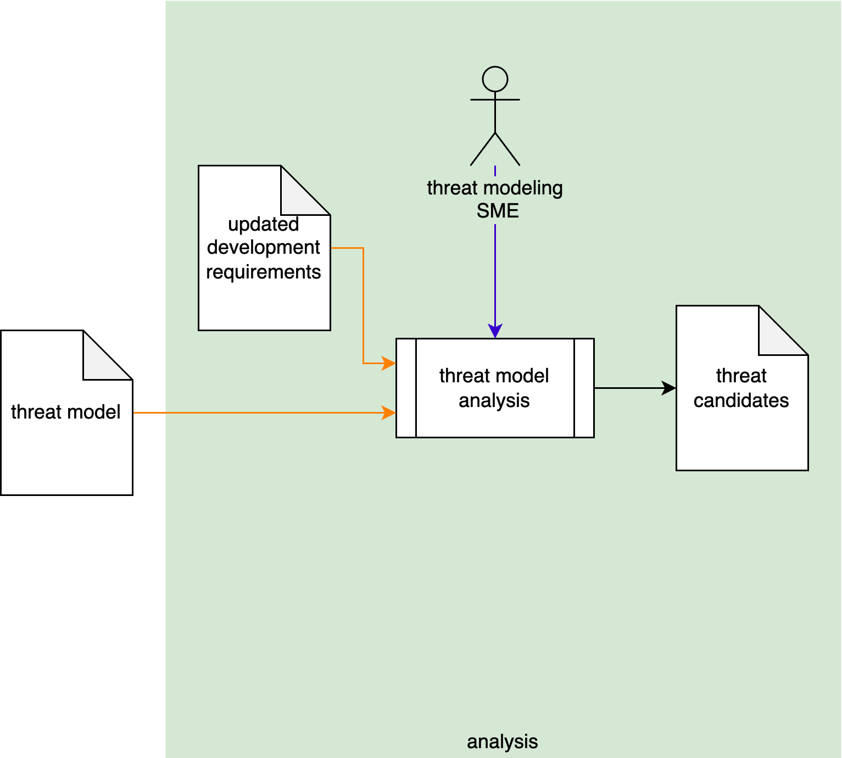
Using the threat model, the threat modeling SME analyzes the model with the updated development requirements (generated during the Element-level Security Requirements process) as a basis to create a set of threat candidates.

Theory
The AVCDL Understanding TARA in an AVCDL Context ^{[5]} elaboration document notes that the analysis activity equates to the threat scenario identification and attack path analysis activities of various standards. This is shown in the following diagram. This is the fundamental task of model analysis.
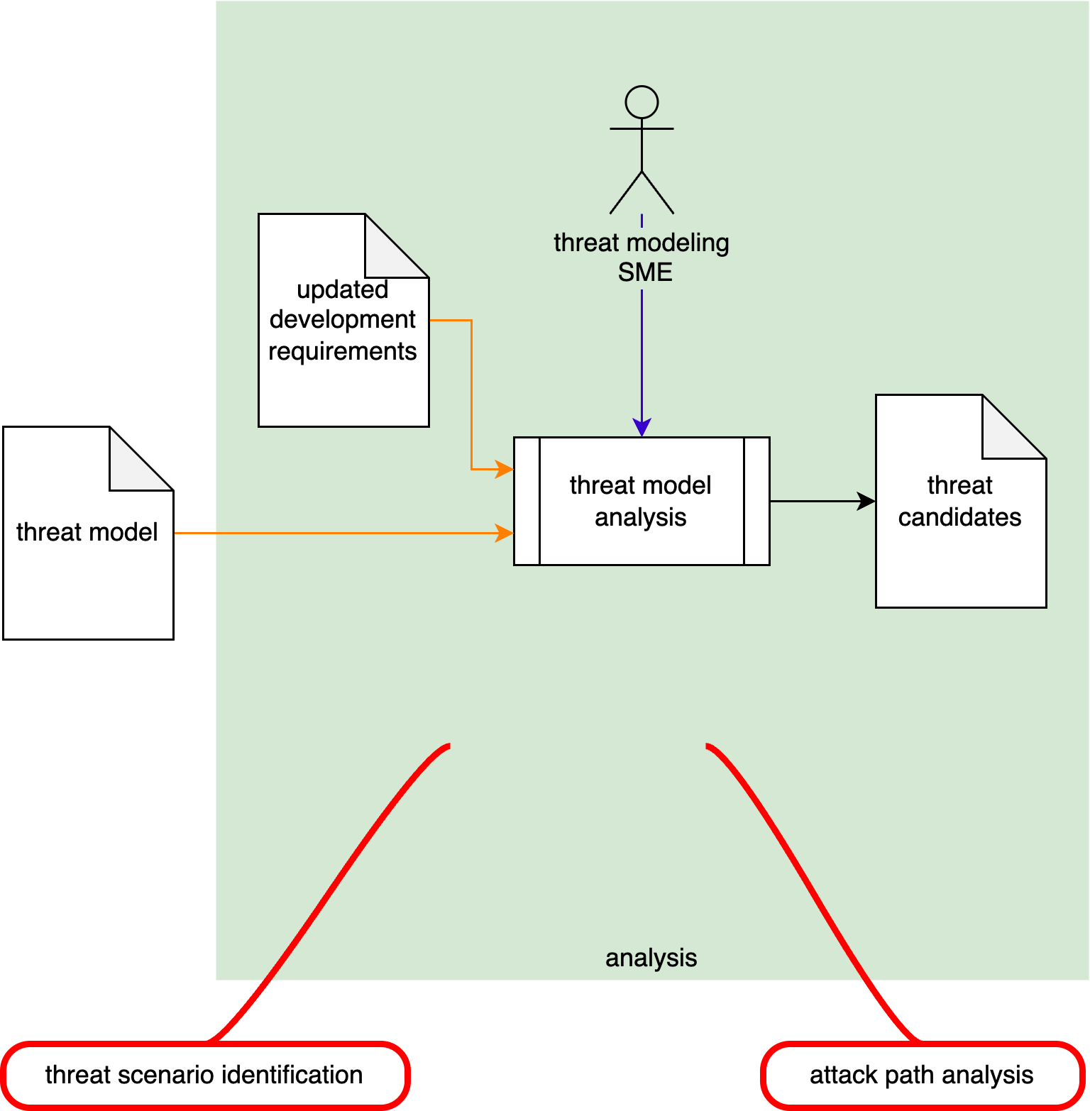

Scope
When performing threat model analysis, it is essential to limit the scope to that of the element under consideration in the context of the element’s threat model. As a reminder, the goal of the threat modeling exercise is to establish that appropriate controls are in place to ensure the cybersecurity posture of the element, not other elements which connect to it. When properly created, the threat models of multiple interacting elements will require no modification if composed into a larger abstraction.
Note: It is important to not treat the threat model analysis as an opportunity to update the threat model. Discrepancies in the model should be addressed as feedback from the triage activity.

Goal
The goal of threat modeling is the establishment of a set of controls necessary to ensure that data crossing a threat boundary can do so securely. Threat modeling cannot assess whether behaviors within individual processes are correct.

Data Flow Diagram Entities
The DFD entities and their attributes are covered in detail in the AVCDL Threat Modeling Report – Model Creation ^{[7]} procedure. To review, these are resources, processes, interactors, boundaries, and data flows. Their symbology is shown below.
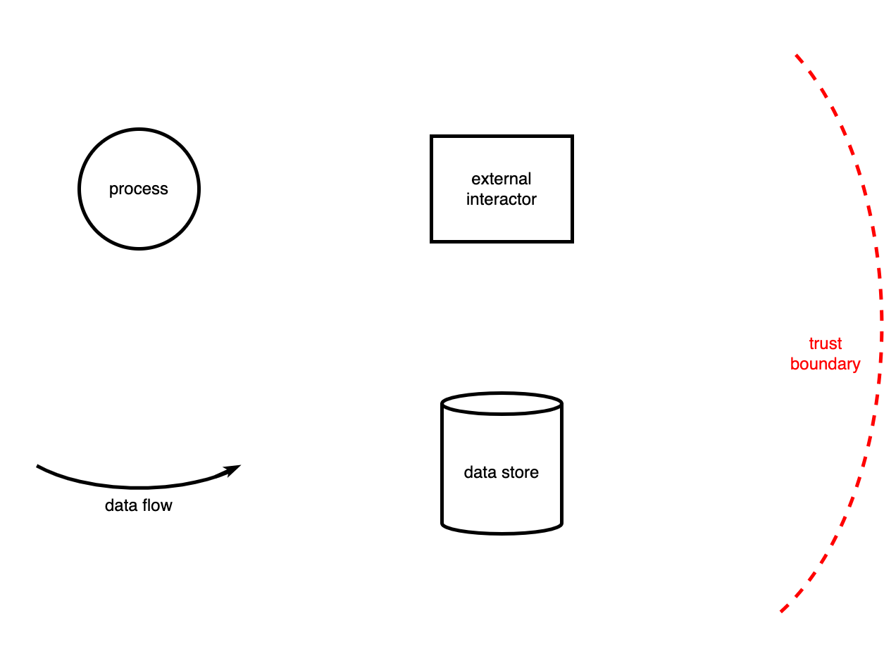

Methodology

Fundamental Approach
The fundamental approach to threat model analysis based on DFDs can be explained using the following diagram taken from the AVCDL Threat Modeling Overview ^{[8]} video.
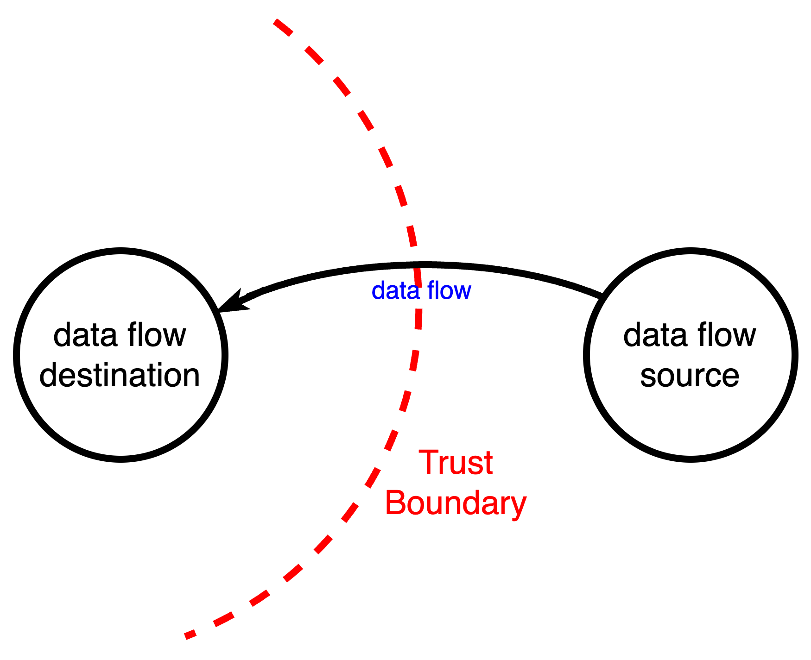
Note: The choice of process entities for the data flow source and destination in the above diagram is arbitrary, and intended to be illustrative, not definitive.
For each data flow crossing a trust boundary, the attributes of the data flow’s source and destination are evaluated against all cybersecurity requirements applicable to the element under consideration.
Note: Because of its basis in data flow analysis, threat modeling cannot reason against all cybersecurity requirements. This is not a deficiency of threat modeling, but rather a reality that emphasizes the necessity of having multiple activities to ensure a sound cybersecurity posture.

Identification of Applicable Requirements
As noted previously, not all cybersecurity requirements can be reasoned on by the threat modeling analysis activity. If the set of requirements comes from a global catalog, such as the AVCDL cybersecurity requirements per taxonomy ^{[10]}, threat model analysis-applicable requirements can easily be identified once. In cases where cybersecurity macro requirements have been created atop a global catalog, it may be necessary to undertake applicability identification.
Note: Although they simplify the requirements process, macro requirements complicate threat modeling and other downstream cybersecurity processes. This is because, unlike the requirements from the global catalog, macro requirements are not uniquely testable.

Order of Analysis
Given the likely number of DFDs associated with the element under consideration, it is important to conduct the analysis so that the number of passes over the various data flows is minimized. The recommended order of analysis is:
- OS-centric DFDs
- Third party-centric DFDs
- Element-centric DFDs
The reasoning behind this order is first that there should exist a stable relationship between the OS and element under consideration. At a certain point, the OS-centric DFD analysis should be complete enough to share among multiple elements.
Note: The mechanism for DFD sharing between elements is not addressed in this material.
Secondly, generally speaking third party processes will be supporting the element. The implication of this is that the third party processes will be assigned a higher level of trust than external entities.

OS-centric DFDs
As noted in the AVCDL Threat Modeling Report – Model Creation procedure, the operating system is comprised of set of components. These include:
- Filesystem
- Network manager
- Process manager
- IPC manager
- Device driver
- Service (daemon)
- Memory manager
From the standpoint of DFD analysis, the operating system is treated as being at the highest level of trust with respect to the element. This being the case, there will be few, if any, issues seen here. Analysis of the OS-centric DFDs is more an exercise in confirming that the lowest level of interaction has been properly accounted for.
Note: It is not the intent of the element model analysis activity to assess the cybersecurity posture of the operating system. This should be done as a separate exercise.

Third party-centric DFDs
Third party and, by extension, open source entities with which the element interacts tend to present the greatest source of threats due to their not being maintained directly. Typical entities include:
- Database manager
- Network protocol
- Device driver
- Service (daemon)
- Process
From the standpoint of cybersecurity, it is useful to treat both third party and open source components as being untrusted. This puts them at the same level of trust as interactors.
Like operating system entities, third party entities tend to be used as supporting abstractions. Unlike operating system entities, because they are untrusted, they can be a substantial source of threat candidates. This is not because of issues within these entities, but rather because the element has not been designed in a way which considers them to be untrusted.
Note: Failure on the part of the element design to consider third party and open source entities as untrusted is especially problematic when these entities are responsible for cybersecurity-relevant tasks, such as cryptography.

Element-centric DFDs
Because of the intrinsic trust between entities within the element, it presents the greatest source of threat candidates. Element entities include:
- Device driver
- Service (daemon)
- Process
Unlike OS and third party-centric DFDs, element-centric DFDs typically take the form of specific workflows. Exceptions to this are interactions with element driver entities and services. Both of these are single-use case in nature and are treated like the non-element-centric entities. These two entity types should be addressed first as they should present fairly easy analysis.
What remains should be a set of element-centric DFDs focused on process entities collected into distinct workflows.
Note: It is just as important to understand the trust relationships between the element and any open source or third-party processes as it is to do so with the operating system processes.

Replication of Threat Candidates
It is inevitable that the analysis of the DFDs created for the element under consideration will result in replicated results. This is due to the various data flow triplets (source, data flow, destination) being reused in multiple workflows. When this is the case, it is important to deduplicate these in order to avoid the problems that duplicate issue reporting creates.
An example of this might be workflows in which logging is done.

Threat Model Analysis Template
The element cybersecurity requirements catalog may be documented using the AVCDL threat modeling analysis template Microsoft Excel workbook ^{[4]}.
Note: Other forms of documentation are permissible so long as they provide the information laid out in this document.
There are five sheets in the workbook. They are:
- Cover sheet
- Revision history
- Reference documents
- Issues
- Legend
These will be addressed in turn.

Duplication of Rows in the Various Sheets
When there is the need to add rows to the various sheets of the workbook, be sure to duplicate an existing row. This is because validation checks are attached to some of the cells which also enables the use of dropdown lists.

Cover Sheet
The cover sheet of the workbook is shown below:
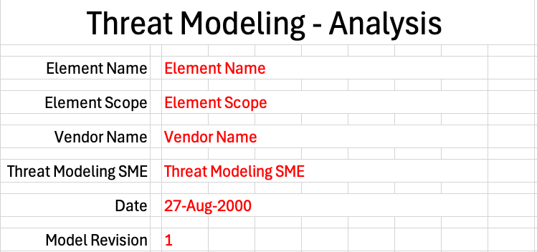
Fields to be completed are shown in red.

Element Name
The element name is the element being modeled.

Element Scope
The scope of the element is left to the discretion of the customer. Examples of element scopes include system, sub-system, component, component software (non-OS), and component OS.
Note: In this context, the customer refers to the entity requiring the activity.

Vendor Name
This is the name of the vendor responsible for the element being modeled.

Threat Modeling SME
This is the threat modeling subject matter expert creating the threat model.

Date
This is the date when the element’s threat model was created or updated. The date should be updated whenever the model is updated.

Revision
This is the revision number of the document. The revision number is a monotonic and increasing integer, starting at 1. It should be incremented every time the document is updated.

Revision History
The revision history sheet of the workbook is shown below:
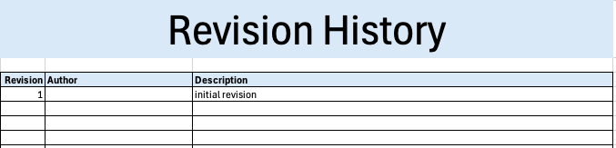

Revision
The revision corresponds to that listed on the cover sheet.

Author
The author corresponds to the threat modeling SME listed on the cover sheet.

Description
This is a brief description of changes made to the threat model analysis since it was last updated.

Reference Documents
Note: These references are those necessary for the creation of the element’s threat model.
Note: References to the element’s threat model and cybersecurity requirements documents should be included.
The references sheet of the workbook is shown below:
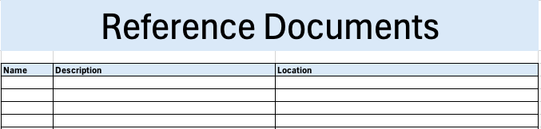

Name
This is the name of the document being referenced.

Description
This is a brief description of the document being referenced.

Location
This is the location of the document being referenced. It may be a physical location or a URL.

Issues
The issues sheet of the workbook is shown below:
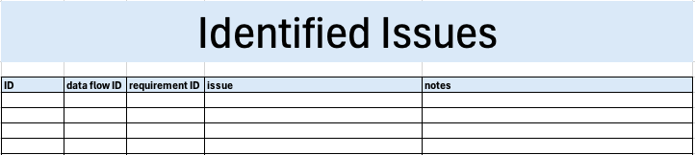

ID
This is the unique element threat model issue ID.

Data flow ID
This is the element threat model data flow ID.

Requirement ID
This is the relevant cybersecurity requirement ID.

Issue
This is the identified issue.
Note: It is recommended that the statement of the issue be minimal and in the form of the aspect(s) of the requirement not fulfilled by the attributes of the entities.

Notes
This is a general notes field.

Legend
Note: This template does not use the legend sheet. It should not be deleted however, as the templates version number is on this sheet.

Exit Criteria
This procedure is considered complete once the generated output has been entered into the organization’s DMS as a document of record.
Note: The processes and procedures for entering documents into the DMS, or the updating thereof, are outside the scope of this document.

References
- AVCDL (AVCDL primary document)
- Threat Modeling Report (AVCDL secondary document)
- Security Requirements Taxonomy (AVCDL secondary document)
- AVCDL threat modeling analysis template (AVCDL template)
- Understanding TARA in an AVCDL Context (AVCDL elaboration document)
- Attack Surface Analysis Report (AVCDL secondary document)
- Threat Modeling Report – Model Creation (AVCDL tertiary document)
- Threat Modeling Overview (AVCDL video)
- Element-level Security Requirements (AVCDL secondary document)
- cybersecurity requirements per taxonomy (AVCDL working material)

